Coaches Academy

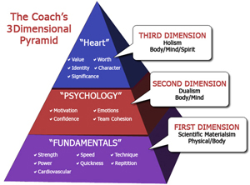
- Research shows that coaches who coach in all 3 dimensions regularly produce athletes who: learn skills quicker (more attentive), achieve higher fitness compliance (work harder), experience shorter rehab (recover from injury), are more adaptable to new conditions (“on the road”), possess freedom to be creative (“are gamers”), develop deeper relationships with other players and coaches (learn life lessons).
- Only about 15% of coaches intentionally coach beyond the 1st Dimension.
- 70% of athletes will fail to reach their full potential on & off the field because of 2nd Dimension issues.
- The “Coach” is the single-most influential authoritative figure in life of today’s adolescent.
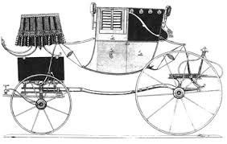
What is the role of a coach?
A coach is somebody that gets people to do what they don’t want to do in order to attain what they want to attain. -Tom Landry
“to do what they don’t want to do” requires Imagination
“to attain what they want to attain’ will require Effort

In the 1500’s a “coach” was defined as a covered carriage that takes a person of importance from where they are to where they want or need to go.
People of importance…our kids…our treasure
Covered carriage…you provide protection, safety when they feel safe they are free to take risks, make mistakes where real learning happens.
What does it mean to compete?
-Comes from the Latin word: Competere
“A coming together to agree; to strive together”
-An unhealthy understanding of competition can lead to a lack of cohesion on your team.
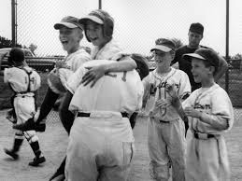
-If your opponent is viewed as the “enemy,” the physical nature of sport often escalates to become violent.
-Play is life giving, competition is life draining and requires recovery time.
To go deeper go to: www.fcacoachesacademy.com

Pre-season
- Coach the parents-set the expectation; Communicate the win: Attitude & Effort
  - Ask the parents to answer in writing, “Tell me one thing about your child that can help me coach them better?” (nothing to do with 1st Dimension stuff, that is your job as the coach)
  - Ask the player to answer this question: Is there something they want to get better at this season?
In-Practice
- Design ways for them to compete; When pitching to smaller kids, pitch at their level; no standing!
-Teams of 3, no glove game (use softer ball, could even use a tennis ball)
-Relays-throwing, catching, running (have a prize, doesn’t have to be big)
-Relay throw
-Ground ball challenge – engage the entire team (can do the same with fly balls)

In-Game
- Map out inning by inning lineup and stick with it:
Order | # | Name | 1st | 2nd | 3rd | 4th | 5th | 6th
1) | 11 | Eunice |  | CF | SS |  | CF | CF
2) | 0 | Natalia | 2B |  | P | P | C | 2B
3) | 10 | Erin | LF |  | 3B |  | 3B | RF
4) | 20 | Kamari | 1B | 1B | 1B | 1B | P | 1B
5) | 2 | Karis | CF | 2B | - | CF |  | LF
6) | 1 | Destiny | P | P | C | C | 1B | P
7) | 18 | Haily |  | RF | CF | RF |  | 3B
8) | 2 | Johanna | SS | SS | - | SS | SS | SS
9) | 16 | Ava | C | C | 2B | 2B |  | C
10) | 3 | Liberty | 3B |  | LF | 3B | 2B | -
11) | 12 | Jacquelyn | RF | 3B |  | LF | LF
12) | 6 | Jayda |  | LF | RF |  | RF

- Designate a coach to direct the outfielders, one for the infielders so they hear one voice
- ENCOURAGE…Harp on the positive
- Be prepared with some humor
- Reward/Highlight Effort and Attitude (Put in on your lineup, Designate a coach to do this job)
Play of the Game, Defensive Stopper, Heads up Baserunning, Attitude of Gratitude, Hustle to position, Hustle off the field, Doing what's right on bench, Heads up on deck

Post Season
- Letter to parents of appreciation.
- Letter from parents to kids of what they observed in them (no 1st Dimension stuff)

